**Covid-19**

**Good hand hygiene remains a critical and central part of the scientific advice in controlling coronavirus transmission. All campus users must be encouraged to engage in regular hand-washing and/or sanitising. Sanitiser stations and dispensers have been positioned around the College. Staff and students are encouraged to wash/sanitise their hands on arrival at the College, before and after breaks, and on departure. Staff and students are also encouraged to bring their own sanitiser to College and use it frequently. Posters have been produced to support regular hand cleaning and good hygiene.​**

**​**

**Students and apprentices must provide their own face covering. Students will be told that if they repeatedly arrive at College without an appropriate face covering or if they repeatedly fail or refuse to wear one when asked to, they will be removed from campus.**

**In some classrooms, the number of occupants might mean that a face covering/face visor becomes compulsory. They are also compulsory in indoor areas of the College, including in corridors, refectories until seated, and in classrooms until a staff member has invited students to remove them. If a student does not have a face covering, the student should be sent to the appropriate curriculum manager who will have a small stock of disposable coverings to distribute, or to one of the central locations where these will be available (reception, gate etc). As a breach of Health and Safety rules, a student who repeatedly forgets or refuses to wear a face covering will be removed from the campus for the day, and a decision taken by the curriculum manager on whether to address this through the disciplinary policy.​**

**The College will start the academic year delivering what is now known as the Model 2 Timetable. The normal timetable, based on a full return of students to campus based lessons, has been prepared and, in this context, it is known as the Model 1 timetable. Under the Model 2 timetable, most FE students and apprentices will be on campus for one day a week. There are exceptions and curriculum managers know if any apply in their area. For some students, GCSE teachers will visit defined ‘main qualification’ groups; most GCSE delivery will be online.**

**​**

**The students in a campus on a given day of the week constitute a ‘bubble’. Most staff will inevitably be on campus more than one day a week, though College managers will seek to support home-based working where it is possible and acceptable. The College is seeking to mitigate public health risks: by allowing most students onto site only for one day a week and thereby significantly lowering daily occupancy levels; staggering start times; staggering lunch breaks; staggering end times; putting in place clear advice for the conduct of lessons; establishing room occupancy levels that allow for at least 1m social distancing and requiring the wearing of face coverings on occasions where, unavoidably, this level is exceeded or for other reasons this is desirable; and enforcing the use of face coverings in almost all other indoor areas.**

**Staggered starts have been planned. These starts support the minimising of large congregations of students.  Students are to be told to arrive punctually and to go straight to, and into, the location of their first lesson, which will usually be open. Teachers should be ready to greet them.**

**During a break, students would be permitted to visit a canteen or even the smoking shelter. The breaks will be too short for students to leave the campus. Students will have been encouraged to bring in food and drink, though as noted students could decide to go to a canteen. Students can eat and drink in their teaching room and the staff member(s) should ensure bins are properly used. Where an Area Head believes the teaching room is not appropriate for food and drink to be used, an alternative ‘breakroom’ will be located, as close to the other lessons as practicable. (Presently, we are working with Curriculum Managers to identify these designated spaces, when timetabling is complete.) If a breakroom is being used, the teacher will be expected to escort the class to it, and return to that room to collect the students.**

**Student groups will have a scheduled lunch break which must be adhered to. If students wish to use College refectory services, they are expected to use these during the first 30 minutes of their break in order to control student numbers in refectories. Students can purchase food via cashless pay systems. At Colchester, either from the ‘Eat Central’ refectory in C block or a new Costa Coffee shop outlet in what was the Diner in HE Centre. C block refectory is open from 08.00 to 16.00, and the Coffee shop 08.00 to 14.00. C Block will serve hot food options to take away with minimal seating. The K Block Refectory will be accessible during College opening hours for vending and seating will be available. Students are permitted to leave the campus during their lunch break.**

**​**

**TERM DATES**

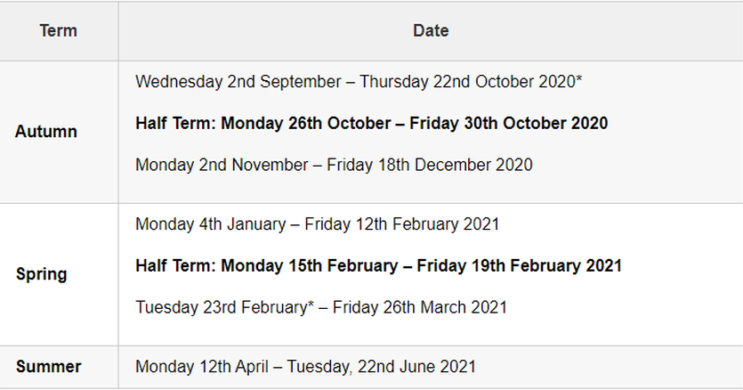

**Equality & Diversity**

**​**

At Colchester Institute we strive to make sure that all students and staff are treated with dignity and respect and that everyone is given the same opportunities to succeed.

​

We are all responsible for our behaviour and should not make any other person feel uncomfortable or discriminated against. The College will not tolerate bullying or harassment in any form.

For support or more information please contact Student Services or email Maeve Borges the Equality and Diversity Manager at [maeve.borges@colchester.ac.uk](mailto:maeve.borges@colchester.ac.uk)

​

**Expectations**

**​**

Please do everything you can to attend all of your sessions and arrive on time. If you need to take a day off because of sickness or injury we do understand, but you will need to let us know.

In this instance please ring the absence line using the number on your student ID card.

​

If you are off for more than 3 days in a row you will need to provide us with a medical letter from your doctor or correspondence from a parent or guardian.

​

Please be aware that attendance reports are sent out and students failing to attend without a legitimate reason can be subject to disciplinary action. Parents/ guardians of students aged 18 or under at the start of the course will be notified.

​

Students are expected to behave in a courteous and respectful manner to staff and fellow students. There is no spitting or swearing on campus, neither is possession of alcohol, weapons or drugs allowed on campus.

​

Lanyards must be worn at all times.

TASKS

Lastly you will need to create a final evaluation and complete your ongoing production diary. This can be completed as a written piece or a video.

​

Evidence a wide and detailed account of evaluative and reflective writing. Ensure you have successfully analysed your thoughts and processes and offered an action plan to progress further.

​

Reflecting on your work is the most effective way of improving your skills and thereby developing your ability to produce high quality work. In order to evaluate your work thoroughly you will need to look back at your brief and proposal to establish whether you have achieved the initial plans you set out to complete.

​

​

INTRODUCTION

​

•What was the project task?

•What did you plan to produce for the project?

RESEARCH

​

•What research did you conduct?

•How useful was your research for the development of the project?

•In what way could you improve the research that you carried out and what impact do you think this may have had on the project?

​

FINISHED PRODUCT

​

•Who is the target audience for your 30 second film?

•How have you planned to engage with this target audience with your 30 second film?

•How well received was your 30 second film following the screening?

•What feedback did you receive? Do you agree?

•How could you make improvements based on the feedback received?

•What impact would these improvements have on the audience?

​​

PERSONAL DEVELOPMENT

​​

•What areas have you improved on throughout this project - carrying out research, analyzing research findings, using research to develop your ideas, planning, organisation and time management, filming, editing, writing, directing, Wix website building, writing production diaries, social media professionalism, software skills etc?

•What programmes, tools and processes have you learned to use?

•What challenges did you have and how did you overcome them?

•Which skills do you feel you need to develop further?

•How could the new skills and knowledge developed throughout this project help you with your future education and career.

•Discuss your overall project - what went well and how would you improve it if you had more time or an opportunity to start it again?

​

You must also evidence an ongoing production diary throughout the production stages.

​

You must reflect on all stages of the project. What did you do? Why did you do it? What went well? How can you be even better next time?

​

​

evaluation dates

monday 19th october - friday 23rd october 2020

FINAL DEADLINE

Friday 23rd OCTOBER 2020

​

all work to be uploaded and published on your wix site by this date