**Cinematography**

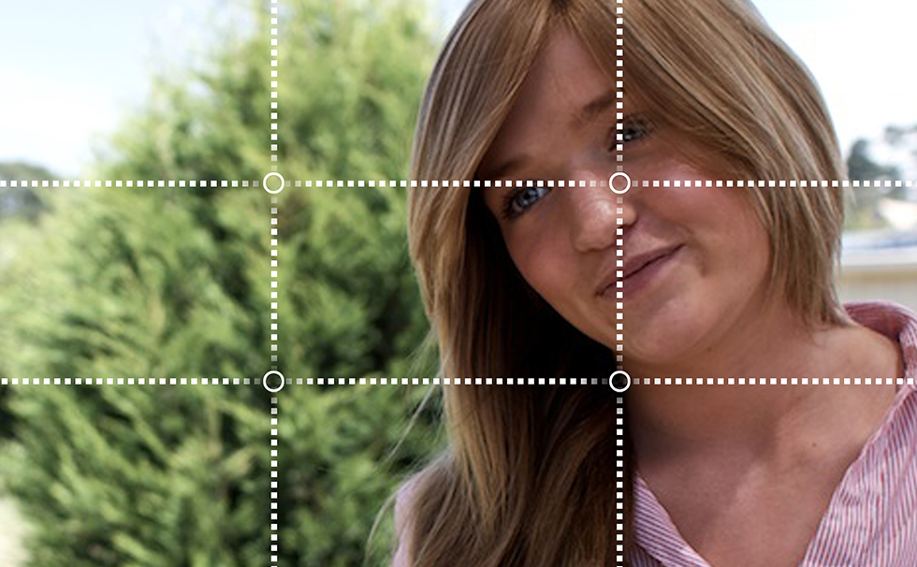

If you’re keen to start making films, understanding the basic terminology of cinema is a must!

**Shot Size**

Shot size refers to how close the camera is to the subject. There are six basic shot sizes:

[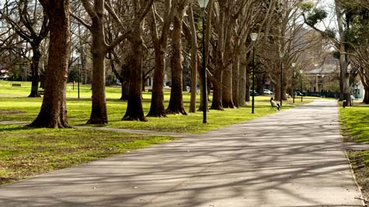](http://lessonbucket.com/wp-content/uploads/2013/04/els.jpg)

**Extreme long shot.** Often used at the beginning of a scene to show where the scene will take place. For this reason, this type of shot is often called an establishing shot.

[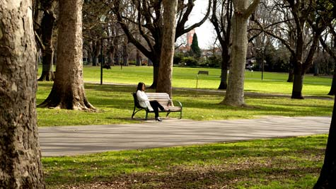](http://lessonbucket.com/wp-content/uploads/2013/04/ls.jpg)

**Long shot.** In a long shot, it is usually possible to discern individuals but there is also a great deal of background.

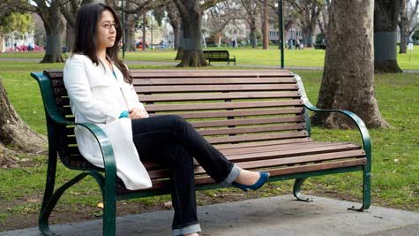

**Full shot.** A full shot shows a character from head to toe. This type of shot is often used as a ‘master shot’ for the scene, showing all the action that occurs.

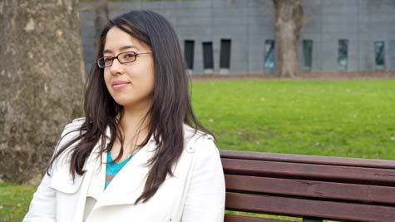

**Mid shot.** A mid shot is often used when filming conversations. It is one of the most frequently used shots in film and television.

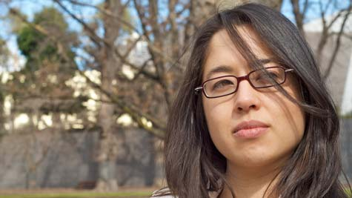

**Close up.** A close up usually shows a character’s face. Often used when shooting conversations, this is also one of the most frequently used shot sizes in film and television.

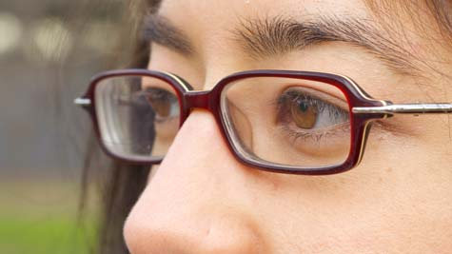

Extreme close ups are used to show small details, such as a character’s eyes.

**CAMERA ANGLE**

Camera angle refers to the angle at which the subject is shot and makes an important contribution to cinematic storytelling.



**Overshot.** The camera is positioned directly above the subject. This is often used in establishing shots, where the camera flies over city streets.



**High angle.** The camera is positioned above the subject, looking down at an angle. This angle makes the subject appear smaller, powerless and more vulnerable.



**Eye level.** This is the most commonly used camera angle in film and television. Whereas most other camera angles are highly stylised, an eye level shot creates a sense realism because this is how we see the world.



**Low angle.** The camera is positioned below eye level, looking up, to imply a sense of power and dominance.

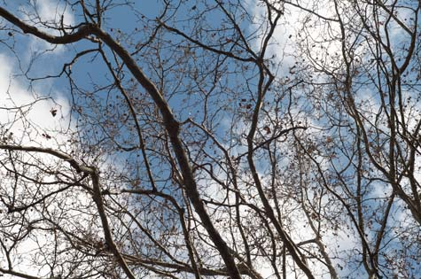

**Undershot.** The camera is positioned directly beneath the subject, looking up. Often coupled with point-of-view shots when the character is looking up at something.

**CAMERA MOVEMENT**

Camera movement is an important storytelling tool. Here are a range of different ways the camera can be moved:

**Static.** A static shot is a shot that is motionless, usually filmed on a tripod for stability.

**Dolly.** A dolly is any sort of moving platform that a camera is mounted on. Professional camera crews often lay down tracks which the camera can be moved along. Sometimes, the camera is mounted in the back of a car. Skateboards, office chairs and supermarket trolleys are the dollies of choice for low budget camera crews. A ‘dolly in’ is when the camera moves closer to a subject, a ‘dolly out’ is when it moves further away.

**Pan.** The camera turns horizontally when mounted on a tripod.

**Tilt.** The camera tilts up/down when mounted on a tripod.

**Crane.** The camera is mounted on a crane, helping filmmakers to achieve dynamic overhead shots.

**Handheld.** Handheld camera movement is often used to achieve a sense of realism. Films like *The Blair Witch Project* and *The Bourne Supremacy* both use handheld camera movement extensively. Handheld camera movement achieves a sense of realism partly because audiences associate this sort of camera movement with documentary film. Poor use of handheld camera movement is one of the shortcomings of many amateur films. The Australian horror film [The Tunnel](http://www.thetunnelmovie.net/), which is distributed online for free, makes extensive use of handheld camera movement.

**Steadicam.** A device that allows camera operators to achieve smooth, fluid camera movement.

**Zoom.** The lens of a camera is used to magnify an image.

**Tracking shot.** A tracking shot is when the camera follows a subject, it may be on a dolly, steadicam or handheld.

**Focus.** When composing a shot, filmmakers also consider what will be in focus. Depth of field is a term which describes how far the camera can see into the distance. Narrow depth of field is when only part of the image is in focus and much of the background or foreground is out of focus. Deep focus is when everything, even distant objects, is perfectly in focus. Orson Welle’s film Citizen Kane was one of the early films to use this technique. A pull focus is when filmmakers shift the focus from one object to another.

**Point of view shot.** A point of view shot shows what a character is looking at. To achieve a point of view shot, you need a shot of your character looking at something. This is usually a close up or mid shot. You then cut to a shot of what they’re looking at.

**Aspect Ratio**

Aspect ratio refers to the width of an image relative to its height. Here are two common aspect ratios that you’ll come across when you’re making films.



**16:9.** Commonly referred to as widescreen, this is the ratio used by most modern video cameras. **Image:** [Jerzy Jalocha N](http://en.wikipedia.org/wiki/File:Aspect-ratio-16x9.svg).

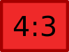

**4:3.** Commonly referred to as standard definition, this was traditionally the aspect ratio used by most televisions and consumer video cameras. **Image:** [Jerzy Jalocha N](http://en.wikipedia.org/wiki/File:Aspect-ratio-4x3.svg).

**Composition**

Here is some great advice for framing up shots, particularly if you’re filming a conversation.

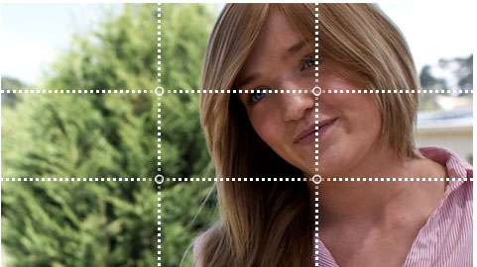

**Rule of Thirds.** The Rule of Thirds is an aesthetically pleasing way to compose the frame. If you divide the frame into thirds, the points of interest should be positioned along these lines or at their intersections. Close-ups like this are a terrific way to shoot dialogue.

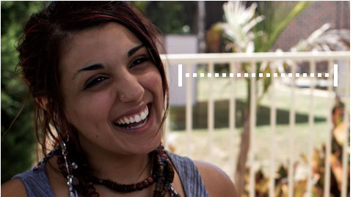

**Look room.** When framing a shot of someone looking at something—like a prop or another character—you need to ensure that there is adequate space between the actor and the edge of the frame.

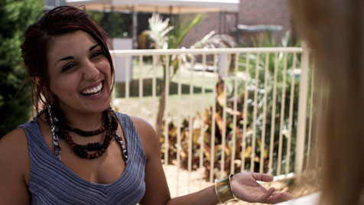

**Headroom.** Too much or too little space above the actor’s head will make the shot look poorly framed. The example here all show appropriate uses of headroom.

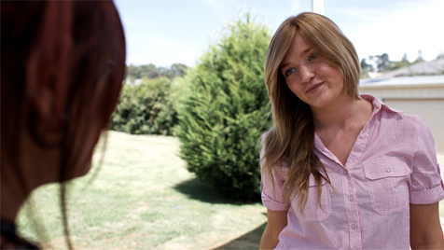

**Over the shoulder shot.** An over the shoulder shot shows someone talking, the person they’re talking to is shown at the edge of the frame. This is a great way to shoot dialogue.

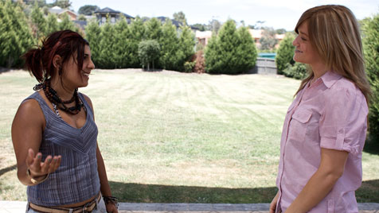

**Two shot.** A two shot is any shot with two characters in it. Two shots are a great way to shoot a conversation.



When framing shots for a conversation or a point of view shot, it’s important to ensure that the characters are looking in the right direction.

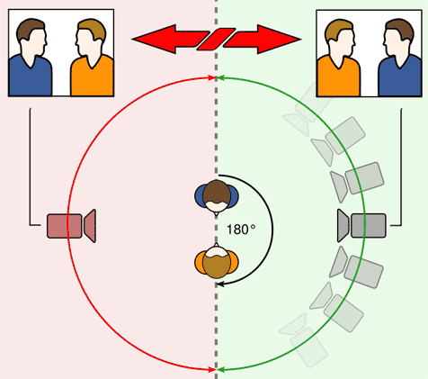

**180 Degree Rule.** When filming a conversation, if you start filming the actors from one side, it’s important to stay on that side. If you cross the imaginary 180 degree line, the characters will not appear to be looking in the right direction. This image is used under the Creative Commons Attribution ShareAlike 3.0.

Being able to film dialogue successfully is very important when you’re making a film. Shooting dialogue out of sequence is very useful because you may not be able to have all actors on location at the same time. To do this, you need to set up the camera and shoot one half of the conversation. Once you’ve framed the actor up, press the record button and get them run through each of their lines. It’s very important that they look in the direction of the person they’re supposed to be speaking to for a few seconds before and after delivering their line. Using this approach, it’s possible to stand off camera and feed lines to the actors which means they don’t have to learn their lines perfectly before filming. When the actors has said all of their lines, remember to get some noddies, cut ins and cutaways. Turn the camera around and film the other half of the conversation.

**COMMON PROBLEMS**

* + **Sloppy composition.**  Framing the shots carefully is crucial. Before you press record, make sure the shot is composed using the rule of thirds and the actors have adequate headroom.
  + **Inadequate lighting.** Check that your character isn’t backlit.
  + **Poor sound.** It is a good idea to take a pair of headphones to the shoot so you can monitor the audio levels while you’re recording. Before you start shooting and the actors arrive on the set, listen to the ambient noise through your headphones. Often there are sounds – like refrigerators or air conditioners – that your ears don’t pick up but can ruin the quality of your audio. Perform a few tests with the actors. The sound of their voice should be clearly audible above any ambient noise. Poor audio quality is very difficult to fix in post-produciton. Using close ups like those shown above necessarily means you have to get the camera and the microphone close to the actors.
  + **Dirty lens.** Check the lens for smudges and dust. Clean if necessary.
  + **Distracting background.** Make sure there isn’t anything distracting in the background or any trees growing from the character’s head.
  + **Noddies.** When you’re shooting a conversation, it’s a good idea to capture thirty seconds of the characters pretending that they’re listening to the other person speak. If there are any problems with the footage of someone speaking, you can cutaway to the person who’s listening, then back to the speaker.
  + **Cut Ins.** A cut in is something related to the action. When you’re editing, it’s good to have a cut in that you can use if there’s a problem with other footage. In your scene a character might be holding a coffee mug. Film thirty seconds of this and, if you run into any trouble, you can always cut in to the coffee mug, then back to the action.
  + **Cutaways.** A cutaway is something unrelated to the action.

**COMMON FILE FORMATS**

When you’re woking in digital video, you will come across a range of different audio and video files, including:

* + **WMV.** A type of video compression developed by Microsoft. It is used in applications like Windows Movie Maker and is a common format of video file when using a computer running Microsoft Windows.
  + **MP4.** A multimedia container format which can contain both audio and video.
  + **MOV.** A format used by Apple’s Quicktime.
  + **AVI.** A multimedia container format developed by Microsoft which can contain both audio and video.
  + **AIFF.** An audio format co-developed by Apple Computer. If you record sounds as an AIFF file, they are usually uncompressed and suited to use in video editing software.
  + **WAV.** An uncompressed audio format developed by Microsoft and IBM. If you record sounds as a WAV file, they are usually uncompressed and suited to use in video editing software.
  + **MP3.** A type of audio compression developed by the Moving Pictures Expert Group. MP3s reduce the amount of data in the file, taking out sounds that most people can’t hear, therefore making the file much smaller. A sound compressed as an MP3 will typically be about a tenth of its original size. As an uncompressed WAV file, for example, a three minute song will be around 30MB. Compressed as an MP3, this file will only occupy about 3MB of space.
  + **AAC.** A type of audio compression developed by Apple. Commonly used on OS X and iPhones. Like MP3s, a sound is usually compressed to about a tenth of its original size.
  + **WMA.** A type of audio compression developed by Microsoft. Commonly used in Microsoft Windows and Zunes. Like MP3s, a sound is usually compressed to about a tenth of its original size.
  + AVIs and MP4s are container formats. This means they hold the audio and video tracks in a single document. The video will usually be compressed with compression algorithms like H.264.